# Asg4 Bug Report

## Bug 1: Incorrect calculation of fines.

When a book becomes overdue by one day, no fine is imposed.

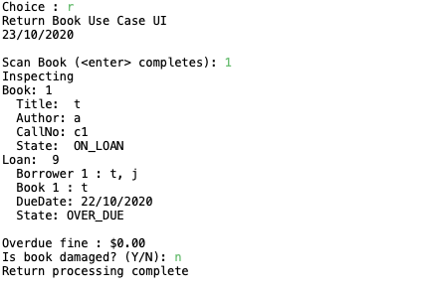

## Bug 2: Incorrect fine amount levied.

When a fine is incurred, the amount of fine reported is half the amount intended.

